**Minutes of General AutoDrive Meeting for 08/09/2024 - Fall 24 Week 1**

1. **Background**

North Carolina A&T State University (NCAT) participates in SAE International’s student project to develop solutions for tomorrow’s self-driving cars. The NCAT team, Aggies Autonomous Auto(A3) meet on a weekly schedule. The meetings are held to coordinate team efforts towards the successful execution of yearly deliverables. This particular meeting was held **virtually** on **August 28, 2024** via the Zoom platform for a one (1) hour duration; specifically, from **10:00am -11:00am**. The Agenda of the meeting was set by the team captain.

1. **Attendees**

In attendance for the August 28, 2024 meeting were the following people:

* Dr. Younho Seong (Faculty)
* Dr. Sun Yi (Faculty)
* Dr Daniel Acree (Faculty)
* Kelvin Kwakye (Team Captain)
* Clement Alabi (Project manager)
* Chandra (Technical Lead)
* Hossam (Technical Lead)
* Abiodun (Technical Lead)
* Azeez (Technical Lead)
* Yoo Sang Chang (Team Member)
* Francis Logarh (Team Member)
* Tunji Ademola (Team Member)
* Chase Jackson (Team Member)
* Jayleen (Team Member)
* Nooruldeen Al Azawi (Team Member)
* Nooralhuda A Azawi (**New Team Member**)
* Muktadir (Team Member)
* Maxwell Sam (Team Member)

1. **Agenda**

* Introduction/Recap of Previous Meeting
* Upcoming Deadlines
* Plan for the Semester by Each Member
* Fall Workshop
* GitHub For Collaboration
* Open Forum
* Closing Remarks

1. **Main Points of Discussion**

* Kelvin opened the meeting by introducing the house to the Agenda for the day, and reminding all team to of his request to have started working on their plans to meet project deliverables(kickoff) for the fall semester. He ended his opening statement for the meeting by inviting any submissions concerning any plans made so far. He also reiterated the various roles for the team leadership as captured in the diagram below;

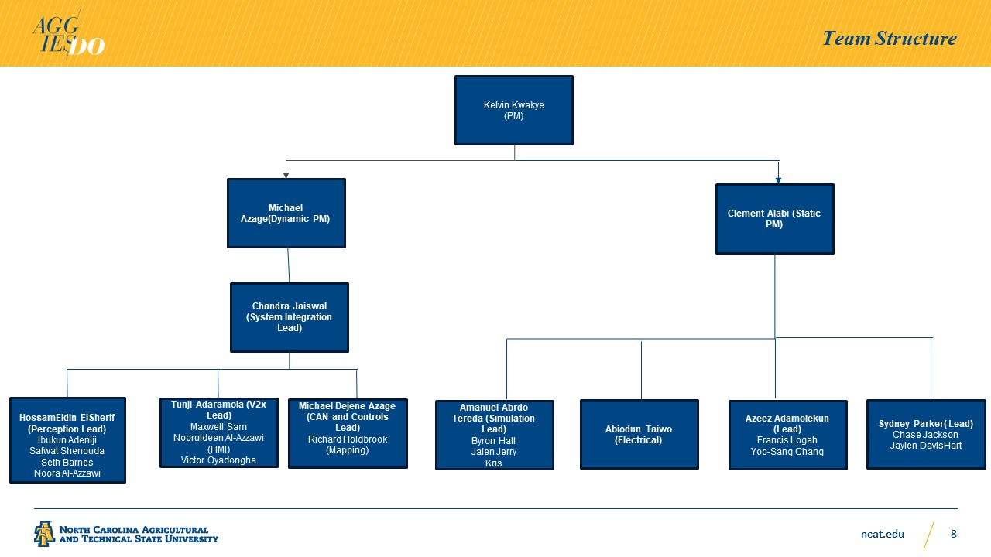

* (**Perception Team submission**): Hossam responded to this by stating that he had already outlined three main areas from this year’s rule book that needed focusing on, namely object detection, radar systems etc. He further stated that he had already assigned team members to the various areas mentioned with the exception of **Nooralhuda** who was a new team member. Kelvin responded to his submission by asking him to firm up plans with timelines.
* **(Electrical Team submission):** Abiodun started his submission elaborating on the state of affairs for hardware /electrical cabling unit. He outlined plans and schematics for redesigning the cabling of the A3 vehicle for improved ventilation and implementation of a failsafe (*instantaneous voltammeter*) to help prevent electrical power shortages during episodes of troubleshooting. Stating also that the team had plans to do a root cause analysis on the battery drainage incident at last year’s competition.
* (**Safety Team Submission**): Azeez, stated that he had received and reviewed the FIA documentation for Year 1-3 of the AutoDrive competition and was looking forward started working work on this year’s document (*FIA Year 4*) using previous year’s work as a template. He also stated that there were plans to develop a checklist to safeguard and reduce errors whilst working on the vehicles. He also intended to organize, mark, and arrange tools to help other team members work more efficiently during team lab hours. To this this Kelvin mentioned that he is implementing Lab cleanup routines for this year, for which he had set a precedence during the summer and would be organizing a follow up cleanup during this weekend.
* (**V2X Team Submission**): Tunji stated that the V2X team needed to extract data from PCAP files provided to the team by SAE, and this would require time, however he had mapped tentative timelines to have that achieved. He also stated that there were still plans to resolve challenges around the V2X team’s challenges regarding some of their deliverables.
* At this point in meeting (**10:33am**) Kelvin quickly interjected to update the entire on changes in travel plans regarding the **Fall Kickoff Workshop.** He stated that 2 people were dropping of the initial list (**Abiodun/Ibukun**), whilst **Jayleen and Kris** were being added to the team list who were attend the kickoff event.
* After Kelvin’s interjection, Hossam quickly asked for audience to draw the team’s attention to important stuff around **Software Requirement Specifications**. He highlighted submission deadlines (Nov 30 and May 1) as submissions for prep metrics and final test results respectively and that generally all teams should think of Metric in all aspects of their deliverables. In response to Hossam’s update, Kelvin stated that he had assigned Muktadir to oversee Software Requirement Documentation preparation and reviews in order to improve our overall position at static events this year, as well as help the Mobility Team with their D4 and D5(which involves cybersecurity) challenges this year.
* Kelvin stated that his expectation for next week will be for all teams to setup their GitHub accounts so the team can have a central GitHub repository. To this, Azeez of the Safety Team mentioned that his team had already created their repository.
* Maxwell Sam offered to help with the creation of the GitHub accounts for all other teams as well as help synchronize the publishing(**pushing**) of updates to the repository to reduce technical challenges and also improve business continuity.
* At this point (**10:55am**) Kelvin asked Clement to recap the discussion so far.
* Clement stated the following in his **recap**;
  + Hossam updated the house on how he had played out work for this semester as well assign team members to the various subunits in order to meet deliverables.
  + Abiodun stated his plans to redesign cabling for improved ventilation and power shortage problems.
  + Azeez stated his plans for improved FIA documentation this year and the development of this year’s safety checklist for vehicle operation.
  + Tunji stated plans for his team to extract PCAP data files with proposed tentative timelines
  + Kelvins assignment of Muktadir to software documentation as well as Hossam’s Software requirement timeline updates

Clement also stated that generally all teams need to add timelines to their plans in order to begin working on GANTT charts to help track team progression for this fall.

1. **Conclusion**

* Not all Teams provided plans for this year’s challenges. (Mobility, Integration, Mechanical team, etc., did not have updates ready yet)
* With exception of the **Safety Team**, all teams were yet to create GitHub repositories for their work.
* Teams need to begin breaking down deliverables for execution
* Teams need to integrate new members to workflow where applicable.

1. **Takeaways/Deliverables**

* All Teams are to review the sections of the rule book regarding their respective challenges for Year 4 and provide updated plans next week
* All Teams should create GitHub repositories to help track deliverable (tasks and code)
* All teams are required to begin breaking down challenges into workable components with timelines which would then help making team GANTT charts.
* Team leadership needs to make sure new members are well integrated and oriented to their roles and tasks